STATE OF INDIANA)
SS)
COUNTY OF CLAY)

Council President Larry Moss called the regular meeting of the Clay County Council to order on Monday, October, 2020, at 6:00 p.m. Council members present were Larry Moss, Jason Thomas, John Nicoson, Jason Britton, Dave Amerman, Pat Heffner, and Jackie Mitchell. Auditor Jennifer M Flater made a record of the proceedings, to wit:

Jackie Mitchell led the Pledge of Allegiance followed by the opening prayer by Dave Amerman.

A motion to approve the September 8, 2020, regular meeting minutes and the September 14, 2020, special minutes, was made by Jason Britton and seconded by John Nicoson. Motion carried 7-0.

IN THE MATTER OF ADDITIONAL APPROPRIATION

Larry Moss read the following:

COUNTY EMERGENCY APPROPRIATION ORDINANCE

Whereas, It has been determined that it is now necessary to appropriate more money than was appropriated in the annual budget; now, therefore:

Sec.1. Be It Ordained by the County Council of Clay County, Indiana, that for the expenses of the taxing unit the following additional sums of money are hereby appropriated out of the funds names and for the purposes specified, subject to the laws governing the same:
Aye Nay
CLAY COUNTY
Jail
Other Services & Charges $ 80,000.00 7

Circuit Court
Personal Services $ 8,295.00 7

Presented to the Clay County Council, read in full and adopted this 5th day of October, 2020.

AYE NAY
Larry Moss /s/
Jason Britton /s/

Jason Thomas /s/

Jackie Mitchell /s/

John Nicoson /s/

Dave Amerman /s/

Pat Heffner /s/
Members of the Clay County Council

ATTEST: Jennifer M Flater /s/
Jennifer Flater, Clay County Auditor

Judge Trout explained the request for $ 8,295.00 for paying out comp time for the three full time employees in Circuit Court. Motion to approve the $8,295.00 was made by Dave Amerman and seconded by John Nicoson. Motion carried 7-0.

Paul Harden explained the request for $80,000.00 is to cover jail medical and meals for the remainder of 2020. Motion to approve the $80,000.00 was made by Jackie Mitchell and seconded by Jason Thomas. Motion carried 7-0.

IN THE MATTER OF TRANSFER

TRANSFER

WHEREAS, It has been shown that certain existing appropriations now have unobligated balances which will not be needed for the purpose for which appropriated and;

It Is Therefore Ordained by the aforesaid County Council that such unnecessary existing appropriations are now reduced and the money transferred to the necessary and proper appropriations in amounts as follows:

Aye Nay
COUNTY GENERAL
Prosecutor
From: Drug Testing (31304)
To: Transcriptions (11216) $ 1,000.00 __7___ ___0__

Veterans
From: Training & Expenses (32701)
To: Veterans Officer (12701) $ 675.00 __7___ ___0__

PRESENTED to the Clay County Council, read in full and adopted this 5th day of October, 2020

AYE NAY
Jason C Thomas /s/
Jason Britton /s/

Larry Moss /s/

Jackie Mitchell /s/

John Nicoson /s/

Dave Amerman /s/

Pat Heffner /s/
Members of the Clay County Council

ATTEST: Jennifer M Flater /s/
Jennifer Flater, Clay County Auditor

Emily Clarke requested to transfer $1,000.00 to cover transcriptions for the remainder of 2020. Paul Sinders requested to transfer $675.00 to cover training for the new Veterans Service Officer for 2 weeks. Motion to approve the transfers for $1,675.00 was made by Pat Heffner and seconded by Jason Britton. Motion carried 7-0.

IN THE MATTER OF CASA GRANT RENEWAL

Sarah Tellechea, with CASA, presented the State Matching Grant and Capacity Building Grant for $20,938.00. These are the same grants the County has had for several years. The grant is effective January 1, 2021 thru December 31, 2021. This a county matching grant with the match coming from salaries and office space.

Motion to approve both CASA grants for 2021 was made by John Nicoson and seconded by Dave Amerman. Motion carried 7-0.

IN THE MATTER OF LIBRARY BOARD APPOINTMENT

Jill Scarbrough, with the Brazil Library, explained that Linda Messmer did not want to serve another 4 year term. Linda suggested Dr. Richard Frankville to replace her on the board. The position will be for 4 years effective July 31,2020 thru July 31, 2024.

Motion to appoint Dr. Richard Frankville to the Brazil Public Library Board for a 4 year term was made by John Nicoson and seconded by Jackie Mitchell. Motion carried 7-0.

IN THE MATTER OF E-911 INTERLOCAL AGREEMENT

Jennifer Flater presented the E-911 Interlocal agreement with Brazil City to the board. Questions were asked why there would need to be an agreement since Brazil City no longer contributes money to the County. Larry stated there was a statute to support. The Sheriff had questions on the termination of the agreement and if the City could request part of the new tax. The Council agreed the new tax was strictly set up for the County.

Motion to approve Resolution 2020-8 Interlocal Agreement with Brazil City was made by Jason Thomas and seconded by John Nicoson. Motion carried 7-0.

IN THE MATTER OF WIC AMENDED SALARY ORDINANCE

ORDINANCE 2020-2

AMENDED SALARY ORDINANCE

An ordinance setting compensation for certain County Employees, for the fiscal year 2021.

Be it ordained by the County Council of Clay County, Indiana as follows:

WIC
Clinic Assistant $16.46 hourly Full Time
CPA $ 23.77 hourly Part Time
Dietician $ 30.09 hourly Full Time

Effective October 1, 2020. Presented to the Clay County Council this 5th day of October, 2020. Approved by the following aye and nay vote.

AYE NAY
Jason C Thomas /s/
Jason Britton /s/

Larry Moss /s/

Jackie Mitchell /s/

John Nicoson /s/

Dave Amerman /s/

Pat Heffner /s/
Members of the Clay County Council

ATTEST: Jennifer M Flater /s/
Jennifer Flater, Clay County Auditor

Jennifer Flater explained the WIC grant had a 3% raise written into it and that the State has approved it. The current grant started October 1, 2020 thru September 30, 2020.

Motion to suspend the rules was made by Dave Amerman and seconded by John Nicoson. Motion carried 7-0.

Motion to approve Ordinance 2020-2 was made by Jackie Mitchell and seconded by Jason Britton. Motion carried 7-0.0

IN THE MATTER OF BUDGET ADOPTIONS

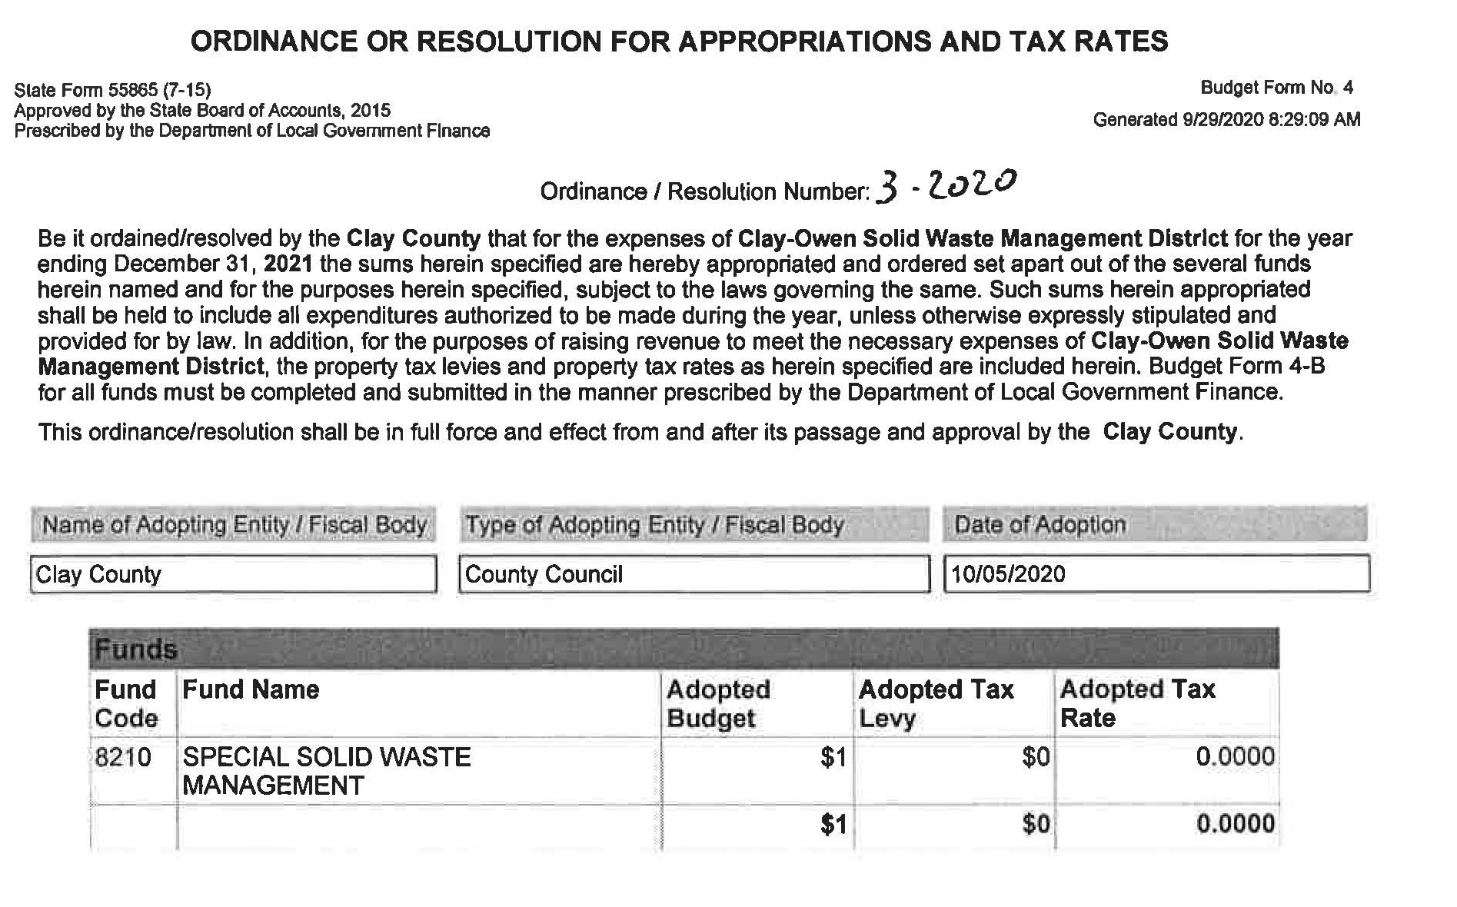
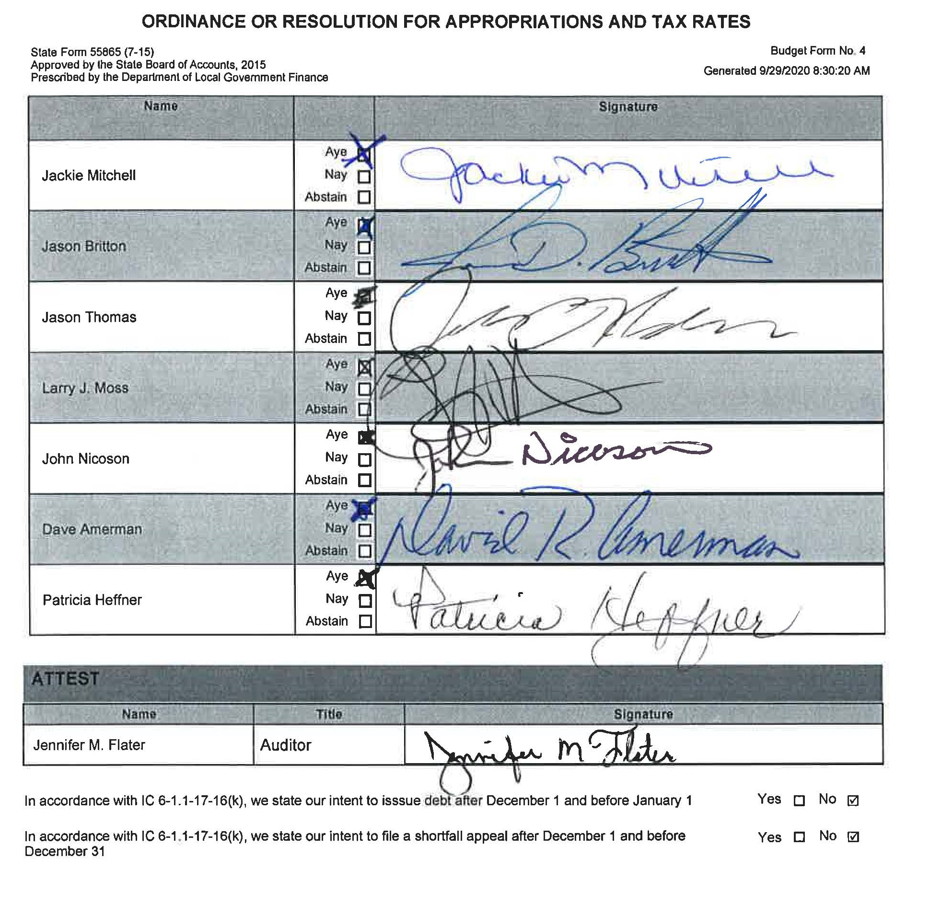
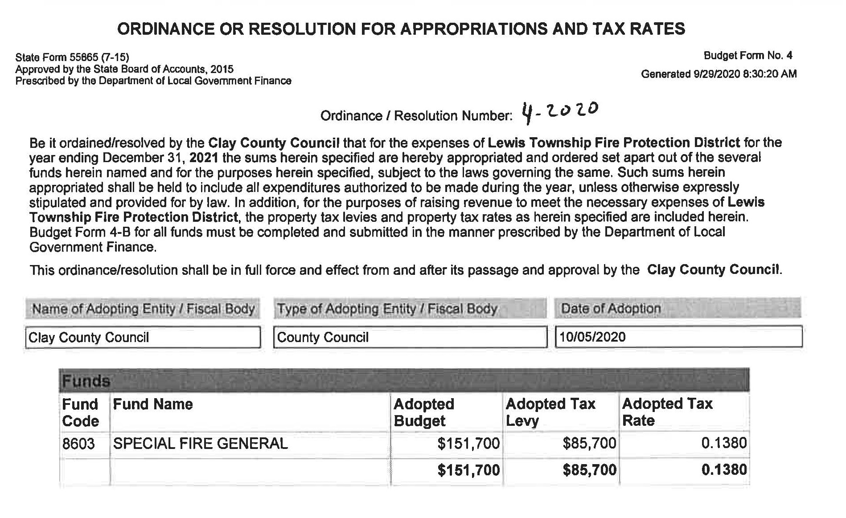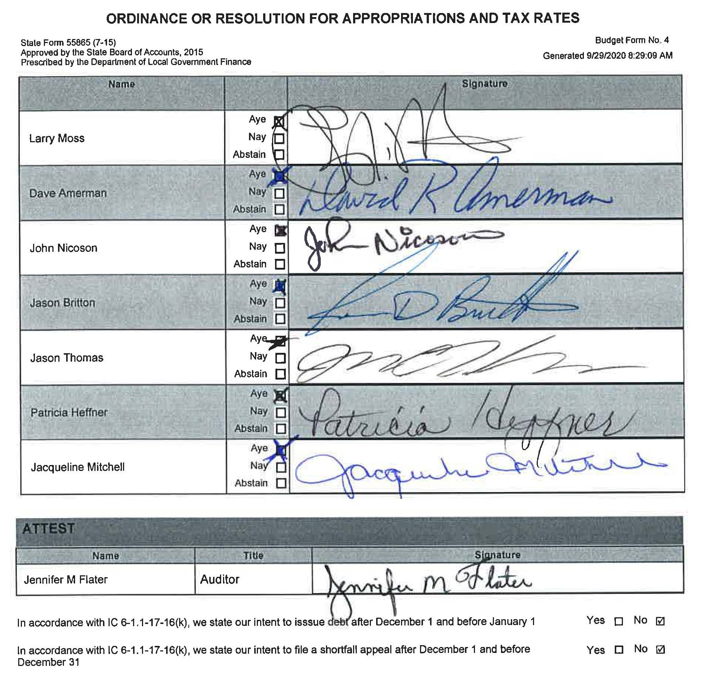
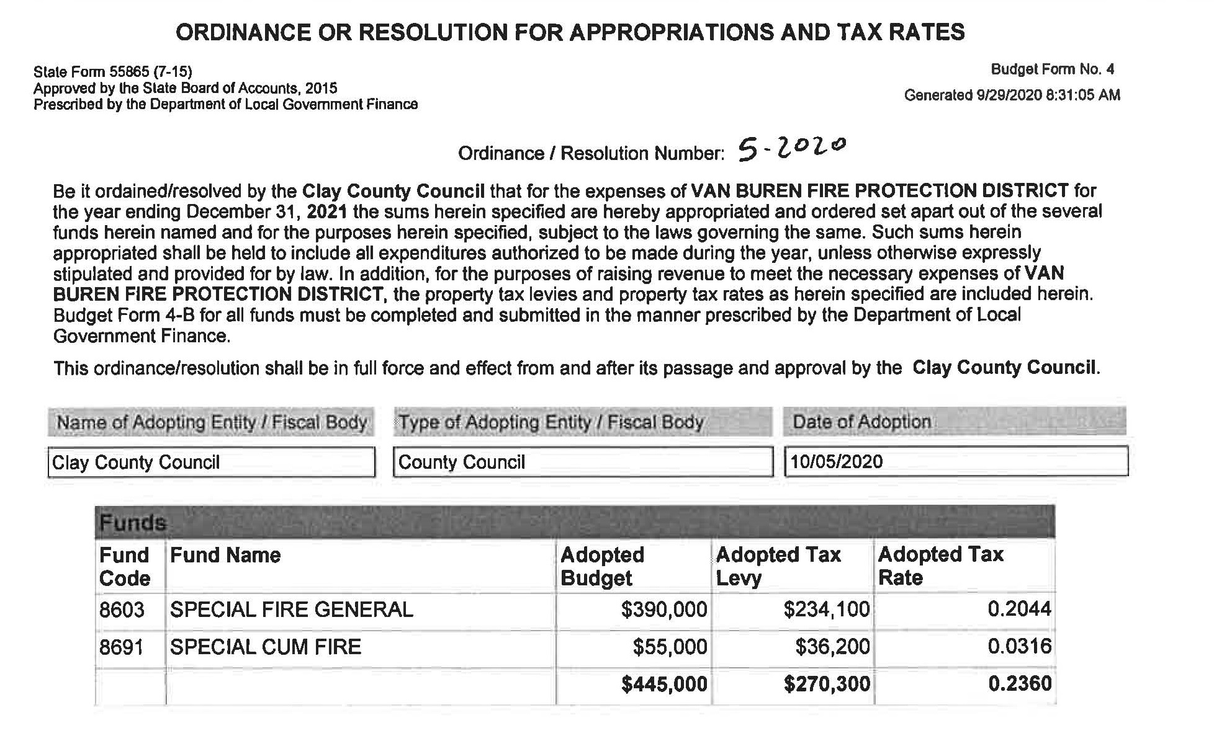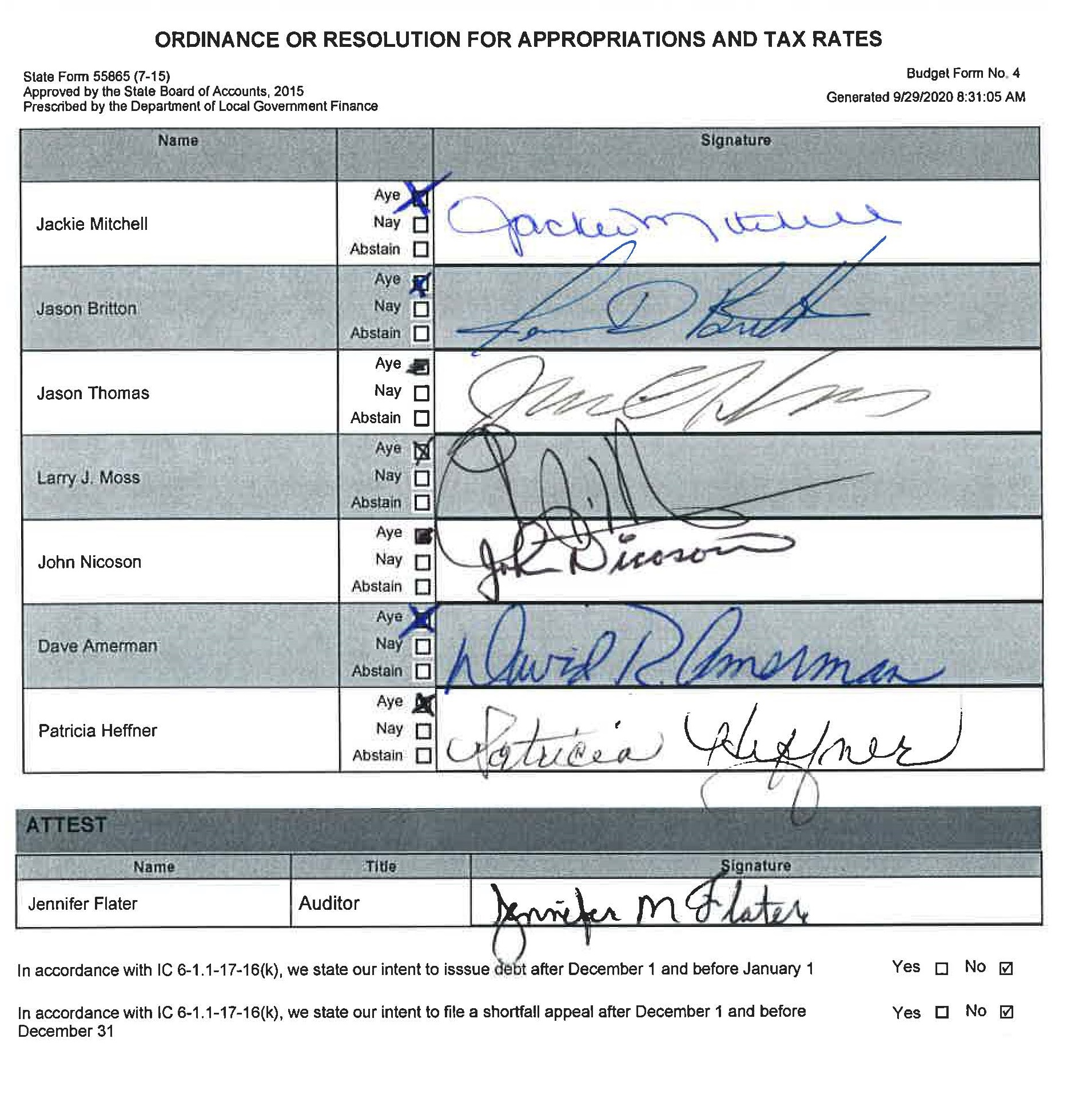
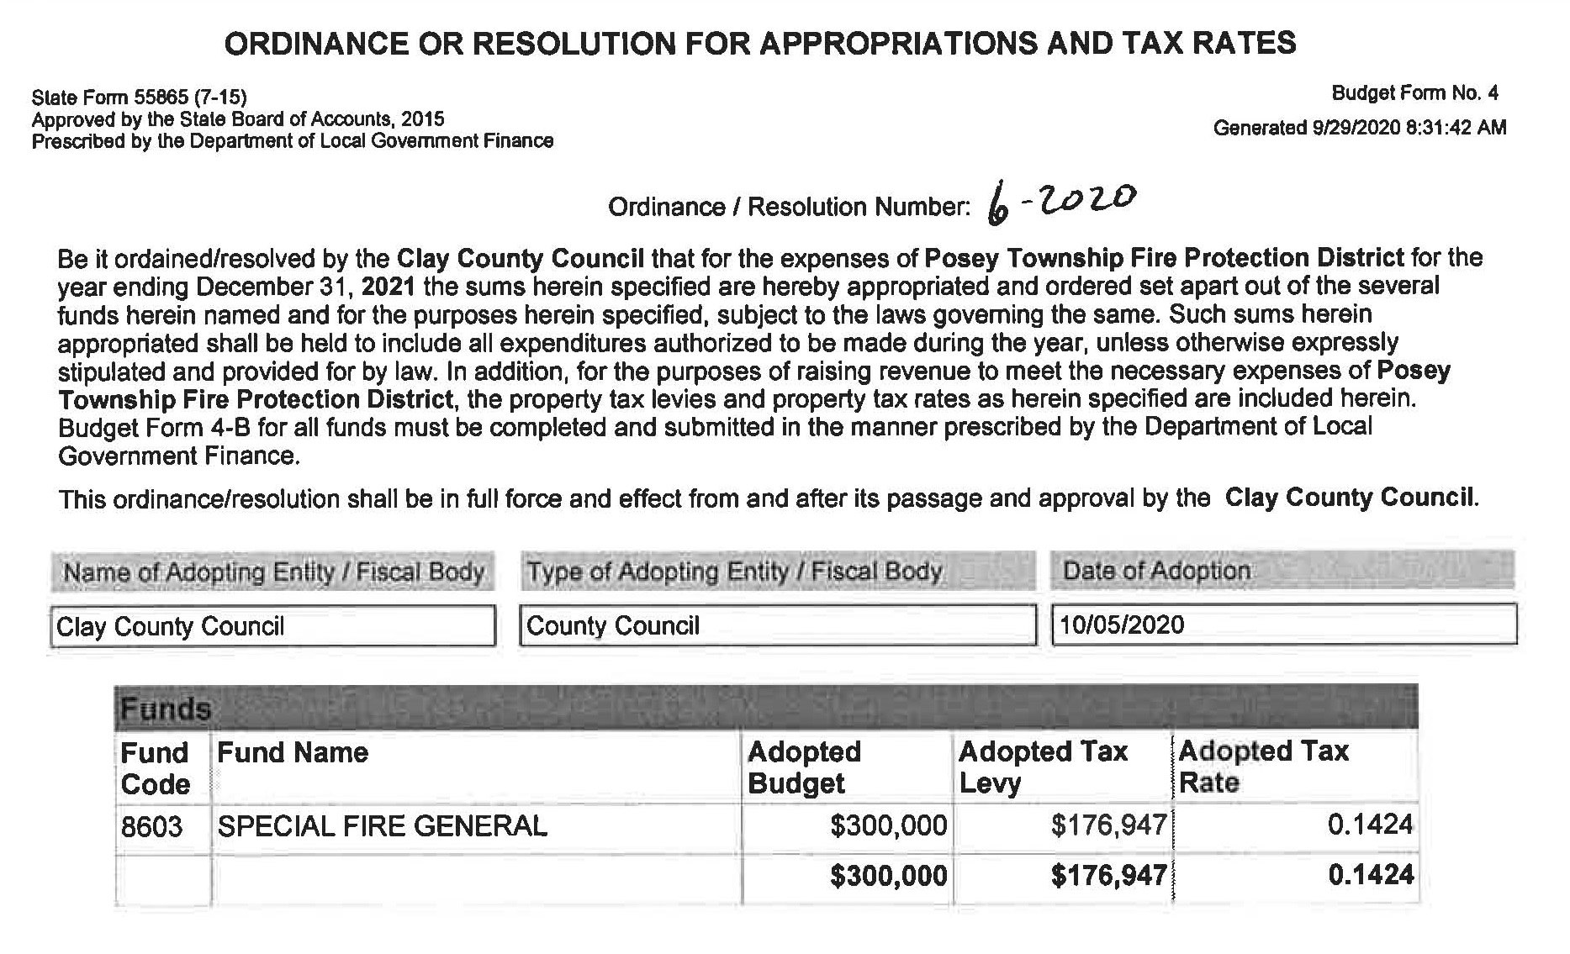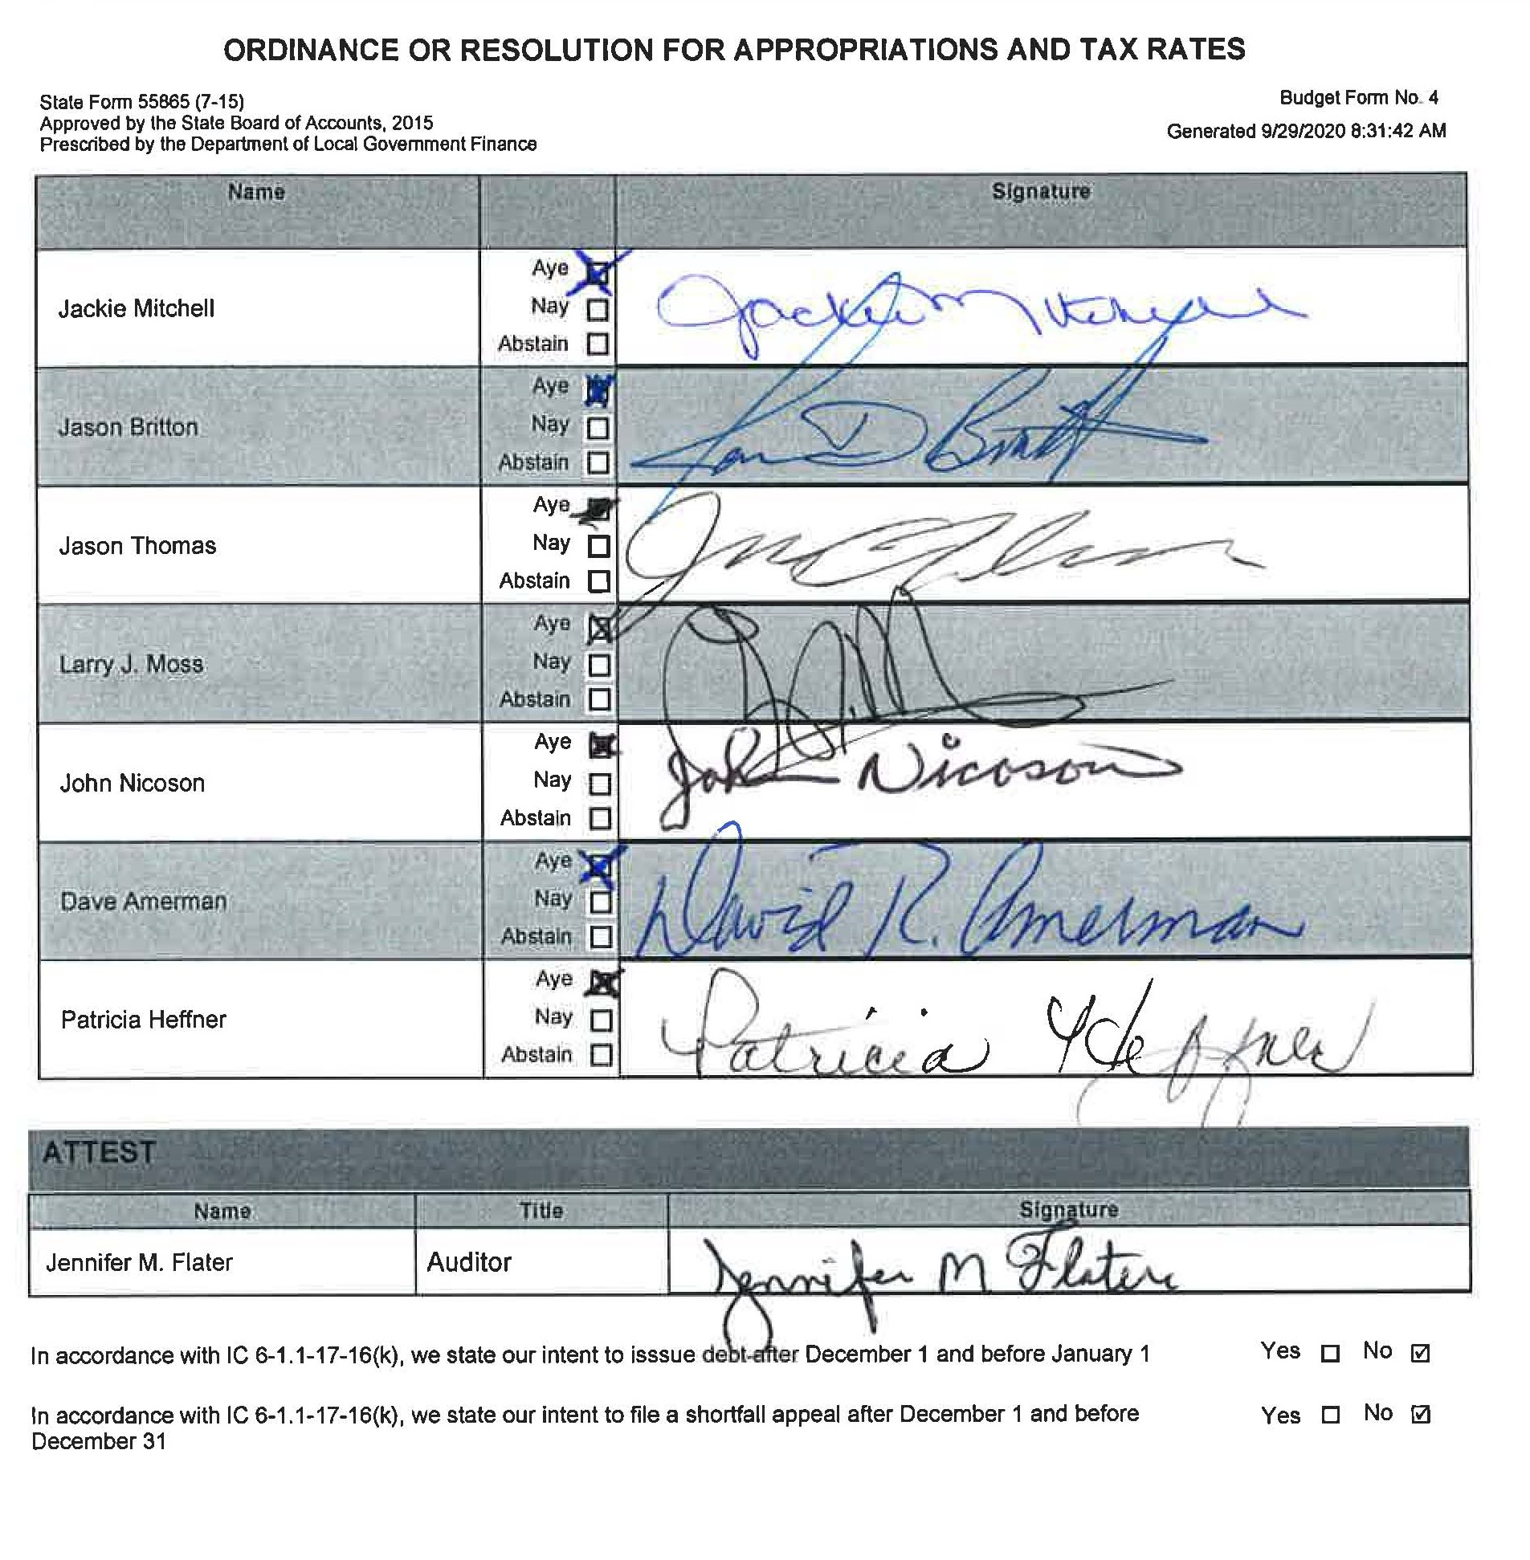
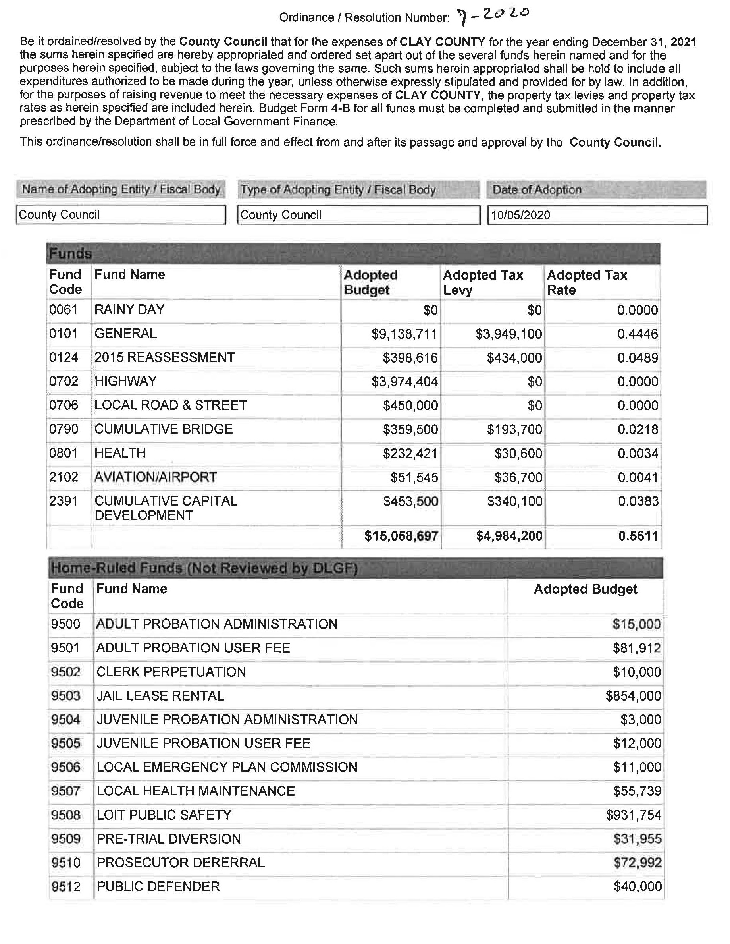

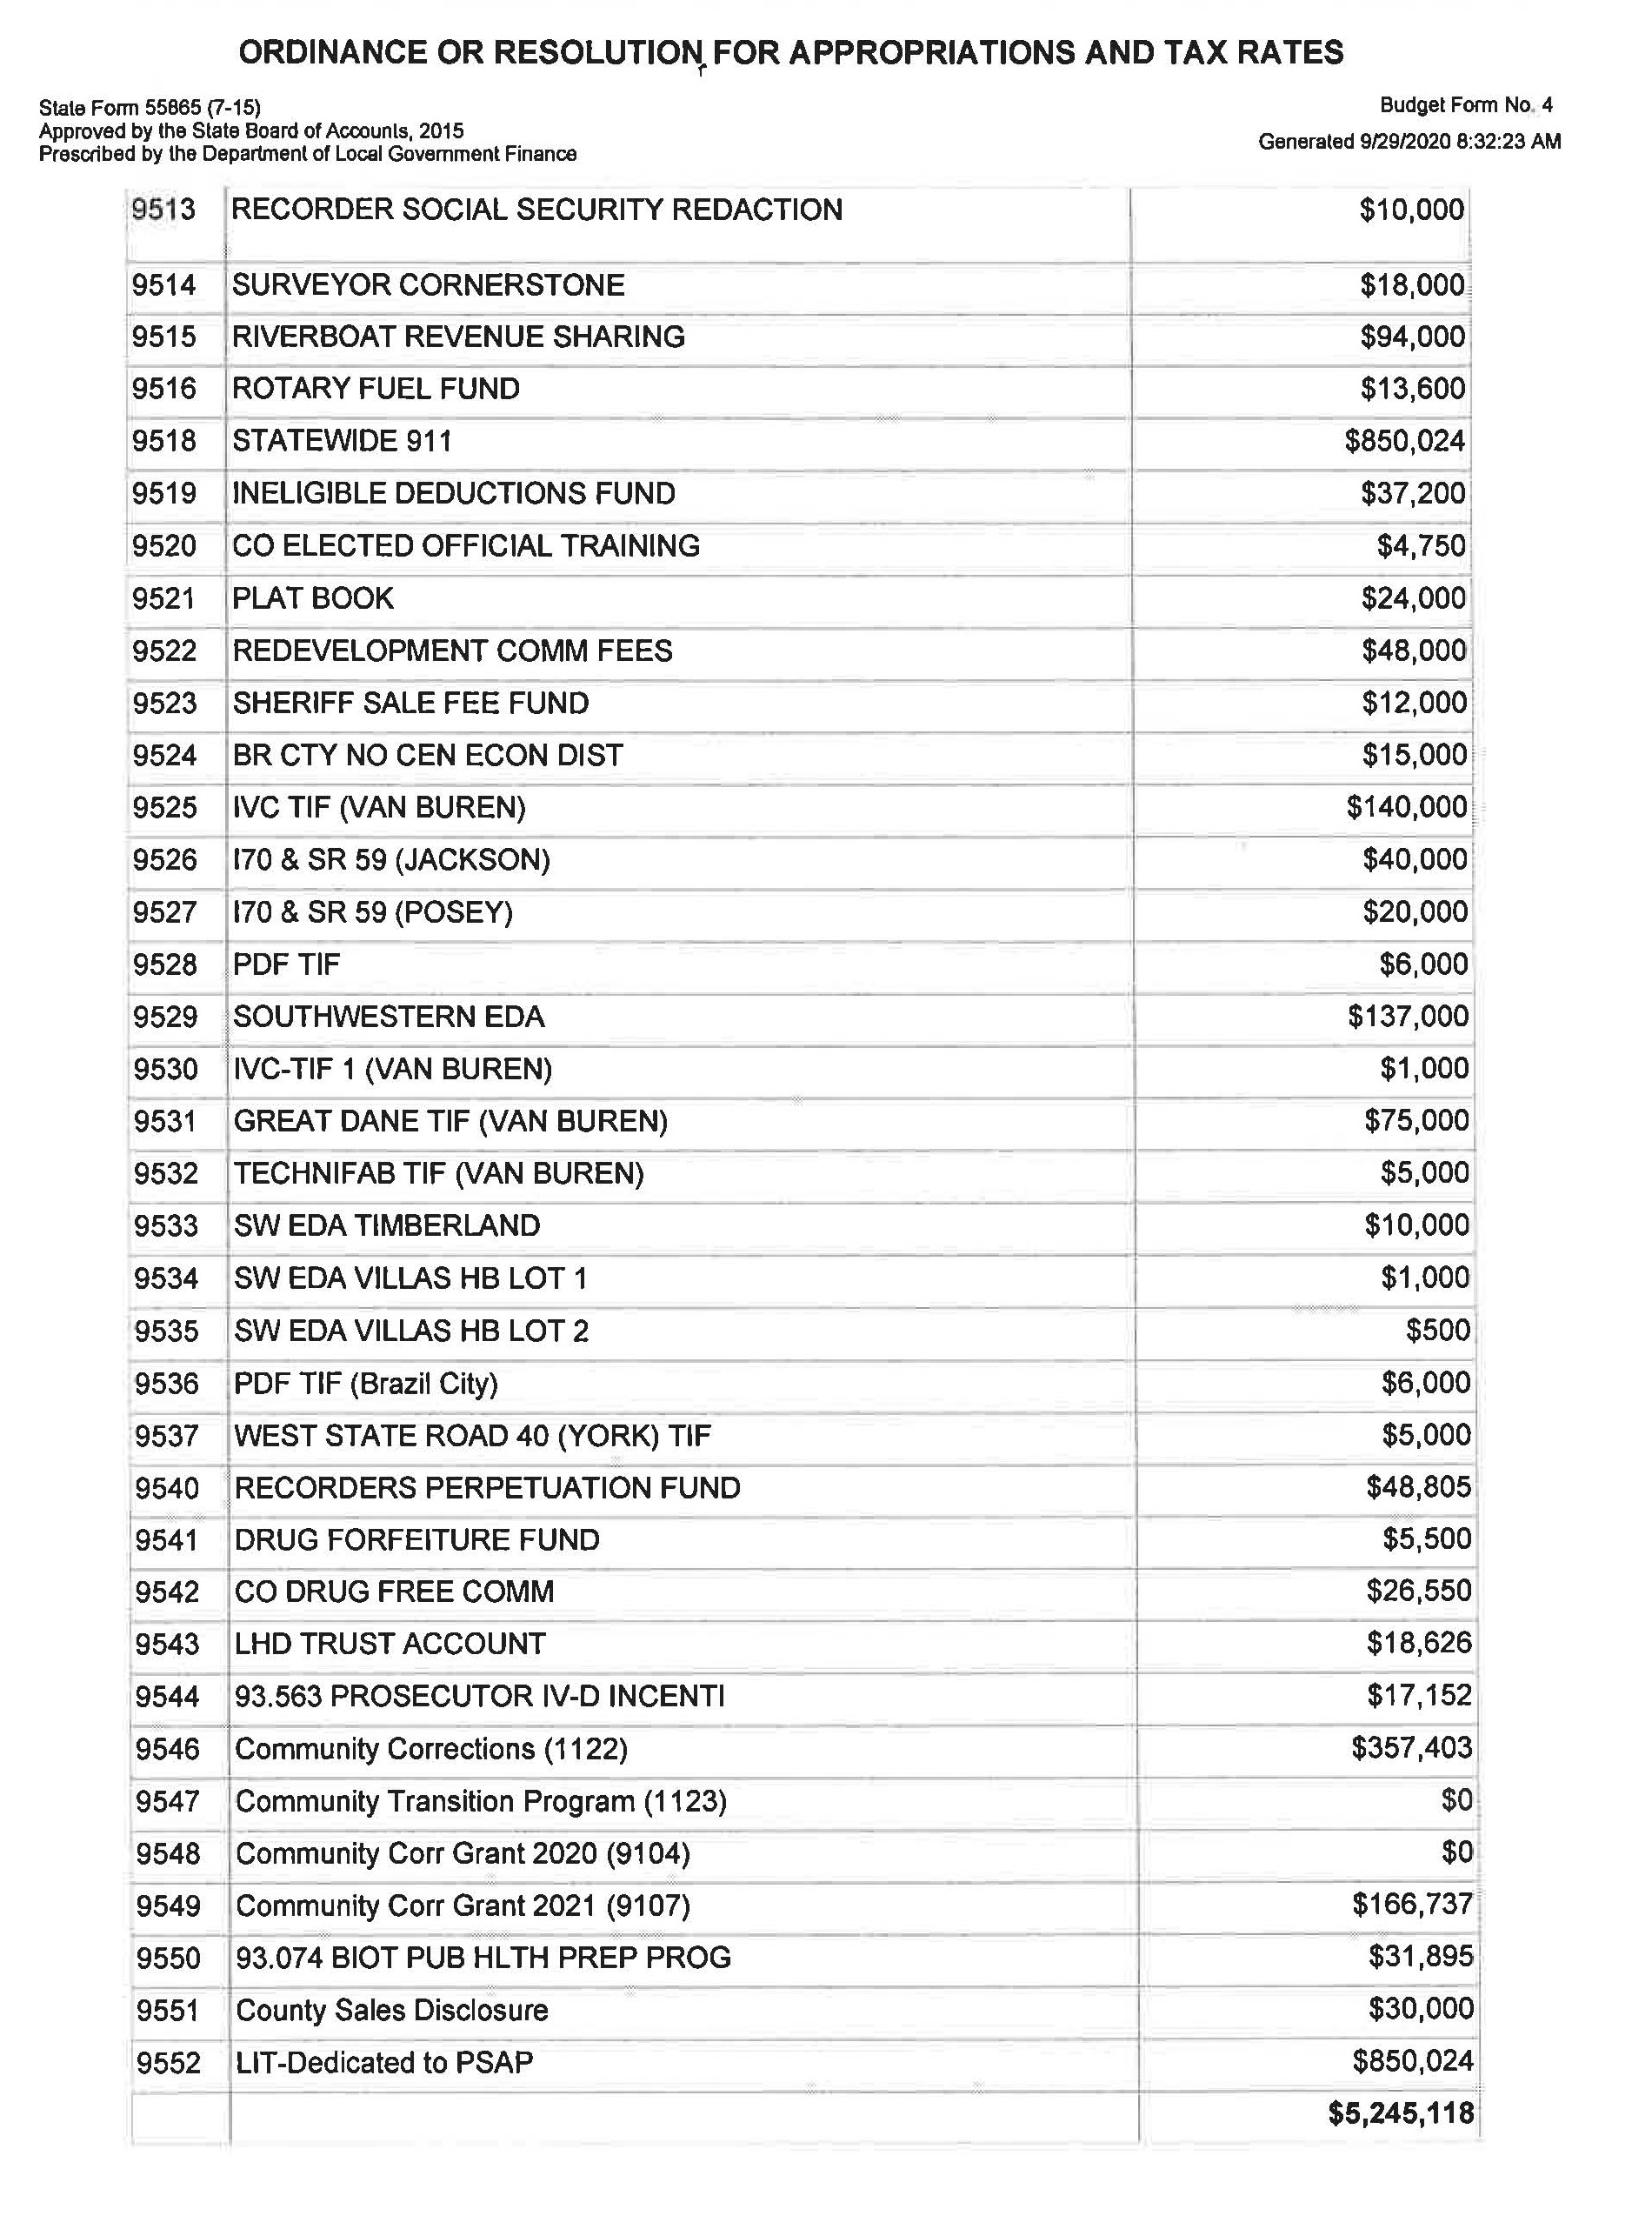

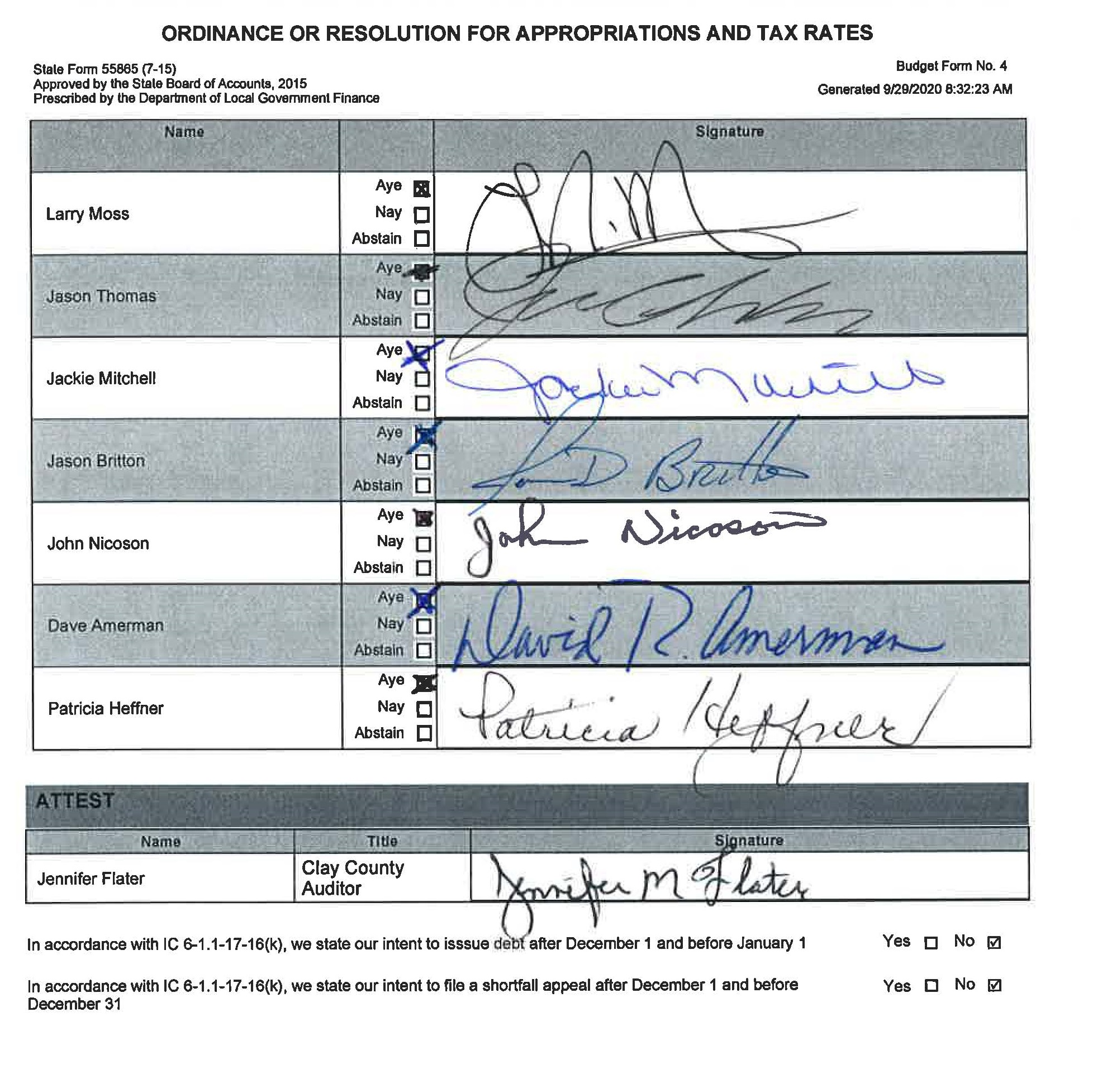
Motion to approve all 5 budget ordinances was made by Pat Heffner and seconded by Jason Thomas. Motion carried 7-0.

IN THE MATTER OF OTHER COUNTY BUSINESS

Jennifer Flater explained the shortage for the Sheriff Pension for 2020 and how the best avenue to correct it. There will be a transfer at the November 2nd meeting for $1,958.00 and in January will submit $19,879.00. This will cover the $21,837.00 shortfall for 2020. Then for 2021 the county will pay the recommended 20 year funding. The Council agreed.

IN THE MATTER OF ADJOURNMENT

There being no further business, Jason Thomas made a motion to adjourn seconded by Dave Amerman. Motion carried 7-0.

Members of the Clay County Council
Attest:

Clay County Auditor

